TOTAL HABITAT
ALGAE CONTROLLER

The Total Habitat Algae Controller helps eliminate filamentous algae without affecting the natural biological filtration process that keeps the water crystal clear and healthy for other living organisms. This electronic ionizer allows for ionized mineral levels that are safe for fish and plants. The residual minerals that are introduced to the water through the electronic ionization of minute amounts of copper, that are safe for fish and plants, disrupt the growth of certain types of algae.

Before you begin

For optimum results and health for your natural water system, test and treat, if necessary, water before installing. The water’s Alkalinity should be 80-120 ppm and the pH level should be 7.2-7.8. It is recommended to repeat this test periodically after installing, especially after any significant water changes.

*If you are a new NSP/pond owner, it is a good idea to test regularly as you get to know your unique system.

Copper ions can be toxic to fish if the alkalinity is below 50 ppm or the pH is below 6.8. Additionally, an Alkalinity reading over 200 ppm keeps the ions dormant. Getting to know your water’s tendencies is important to properly address these types of issues. If you have concerns about frequent tests with these extreme readings, please contact us as it may indicate a larger issue regarding environmental factors that are affecting the health of your NSP or pond. The average NSP or pond, while fluctuating throughout the day and seasons, should stay closer to the ideal readings, if not in the range.

INSTALLATION

Determine the correct spot for the Tee housing the electrode cell to be installed.

Ideally, you want the unit to be after the pump on the discharge line, but you can place it elsewhere if necessary.

The unit must be installed so that it can be situated according to the diagrams provided below.

The electrode cell is attached to a 2” Tee. The kit comes with bushings to reduce to 1 ½”. If you are installing on a different size line, ex. 3”, you will need to purchase the appropriate bushings separately.

It must be level horizontally with the cell placed hanging below the pipe or to the side (do not install with the cell upwards) or vertically plumb (if on a vertical stretch where the water flow direction is going down. (See diagrams) The electrode cell must be in one of these positions to make sure there is no air trapped.

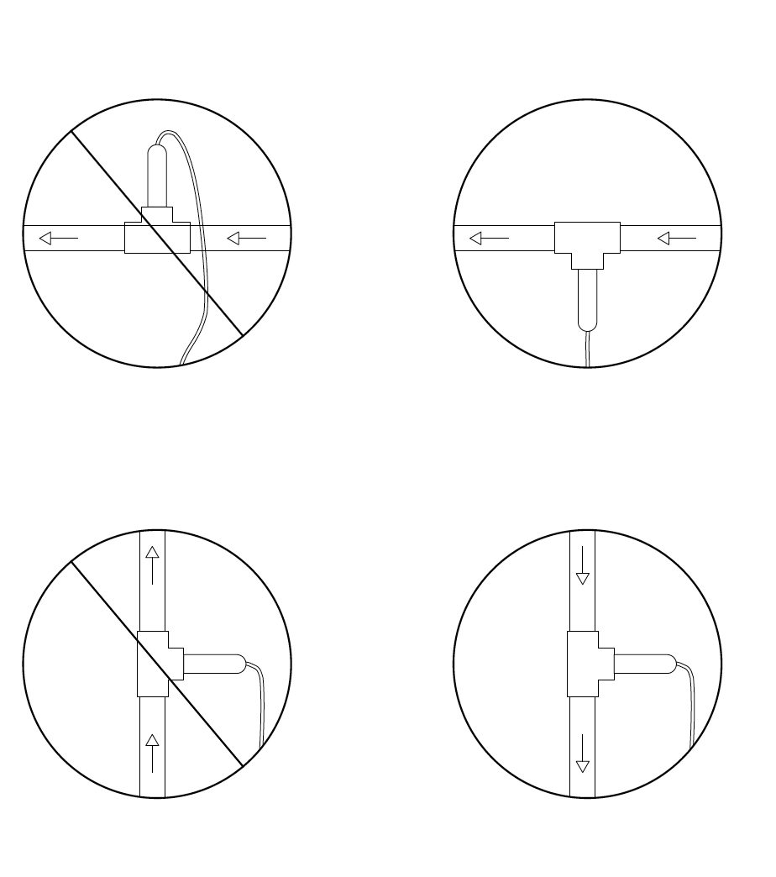
Additionally, make sure there is 9” clearance to allow removal of the electrode cell from the casing. Test by unscrewing the union if you are unsure you meet the clearance.

You will need a straight plumbing run that will accommodate the length of the TEE and allow it to be installed (at least 6” but it may be more. If you are going up or down from 2” or need to add valves or unions, you will need more).

Professional assistance is recommended if you have never done any plumbing. We may be able to assist you remotely in some circumstances.

If the spot you want to plumb is below the water level on your NSP/Pond you must be able to close valves on both sides (intake and discharge) to keep water from flowing out when you make your cut.

If it is not above water level and you do NOT have valves that can keep the water from being drained by gravity you will need to lower the water level of your pond before making your cut. Depending on your system this may be the entire amount of water. Professional installation may be able to avoid this scenario.

DO NOT MAKE ANY CUTS UNTIL YOU ARE CERTAIN YOU WILL NOT ACCIDENTALLY DRAIN THE WHOLE SYSTEM. If in doubt, we may be able to assist you remotely with solutions if you can provide photos of your plumbing and pump.

Placement and plumbing of the unit are extremely important and failure to do these correctly may result in leaks, system drains, and or damage to the electrode. We are happy to assist with concerns, or you may want to consider hiring a professional for installation.

The unit must be plugged into a nearby GFCI outlet. Ensure that the outlet allows the control panel to sit in between the electrode portion of the unit at its determined plumbing spot and the outlet. Do not run the unit on an extension cord.

Anytime the pump is off and water is not flowing through the electrode, you need to unplug the unit. The unit is turned off by unplugging, so be sure that it is easily accessible to you if you need to do so.

To begin installation you will need:

Tools:
A phillips screwdriver
Plumbing glue and primer
Saw for plumbing
Additional Sch 40 PVC parts, if needed

Algae Controller Kit
Full unit with control panel and electrode
Screws
Copper Test Kit
Instant Ions (optional use)

If you have 1.5” or a 3” pipe, you will need additional plumbing parts, but if you have a 2” pipe, you can glue the TEE in directly. 1.5” bushings are provided in the kit. 3” parts of Sch 40 PVC will need to be purchased separately as a separate kit from Total Habitat or from a plumbing supply outlet. Your individual needs may vary. If you do not have a contractor to work with, please give us a call and we may be able to assist you with identifying the parts for your custom needs.
Make the appropriate cut, ensuring that the cut is straight. Size of final cut determined by your specific needs. We recommend using a light sandpaper to get rid of any burrs on the cut edges of the PVC. If you are not familiar with making plumbing cuts, please contact us for assistance.
REMEMBER, do not cut until you are certain the pump is off, valves are closed, or you know that water will not drain from your system.
Glue the TEE in place using primer and PVC glue. The black line on the cell must always be inline with the water flow. If you have unscrewed it for any reason, double check this and make sure that you have used teflon tape when you reattached the cell. If you are not sure how to install the cell you should have a professional contractor do it for you.
Mount the controller on a wall or post ensuring that the ion cell is within reach of the cell power cord. Remove the four screws in the face of the control box, which will reveal four internal sleeves for the mounting screws. Drop the four #8 x 3/4” mounting screws provided into these sleeves. Slide a screwdriver into each sleeve to fasten the controller to a wall or the spa cabinet so that the cell power cord will reach the cell. It is best to install the controller where it is protected from the sun and weather when possible.
OPERATION
Open all necessary valves and start pump
Test the water with the copper test kit to see if there is copper already present in the water. In the unlikely event that it is, treat with a water conditioner that lists that it detoxifies heavy metals.
Plug in the control panel and turn the controller output to MAX. The power light and the cell power light should come on. Turn the output control to MIN and the cell power light will go out in a few seconds. Turn the output control back to MAX and the cell power light will come back on. The cell power light will change color from green to red regularly as the polarity to the cell changes. The cell power light is on when the cell has power. Turning the control down decreases the percentage of time the cell has power.
Once installed and on, check copper levels and dose with instant ions if necessary (Instructions below). With the dial turned to max, reduce once the test reaches 0 .2ppm. The copper levels are to remain low (a reading below 0.2ppm is fine) and should be checked after installation and periodically throughout the year. You may turn the dial up, but be sure to check on it the following days so that it does not get too high. Most units do not need to run higher than the minimum setting the majority of the time, but each NSP/Pond is unique so you may find that yours performs best slightly higher. Keeping it at the minimum setting when possible will extend the life of the electrodes.

The reading should be 0.2 ppm or less. It will run closer to 0 ppm long term. It is ok if it is temporarily higher but be sure to turn the dial down if that is the case.

If you get an extremely high reading (0.8 ppm or higher), turn the unit off and treat your water with a water conditioner (dechlorinator) that specifically states that it can be used to detoxify heavy metals. Check the reading after dosing to be sure it has gone down. This should not be a likely occurrence, unless it was just overdosed with something like the Instant Ions, and may indicate an environmental issue. If you have any concerns, contact us and we may be able to help diagnose the issue.
After 12 to 24 hours, test the water with the copper test kit. If the reading is less than 0.2 ppm, up the dial to half way and check the copper level every 12 hours or so, until the level is at least 0.2 ppm. Once you get the desired reading, set the control panel to minimum setting. This will work on barely perceptible readings. You will only need to test that it is not going higher than 0.2 ppm.
If you have a hard time getting enough of an ion level, make sure the setting is on MAX, the water has the correct Alkalinity and is pH balanced, and the electrodes are not worn out. Do not over ionize the water with instant ions. These should be used sparingly at the initial start up, if at all. If the ion level goes over 0.2 ppm turn the ionizer to MIN until the level drops to 0.2 ppm or lower.

Once a year, unscrew the ion cell, inspect the electrodes for wear, and clean them with a stiff brush. Replace the electrodes when they are just small stubs. Install new Teflon tape or silicone to the threads before reinstalling. Ensure that the electrodes are installed so that the black line is in line with the water flow.

Do not run the ionizer if the pump is not running. Please unplug the unit if you need to turn off the pump that feeds the water flow to the unit.

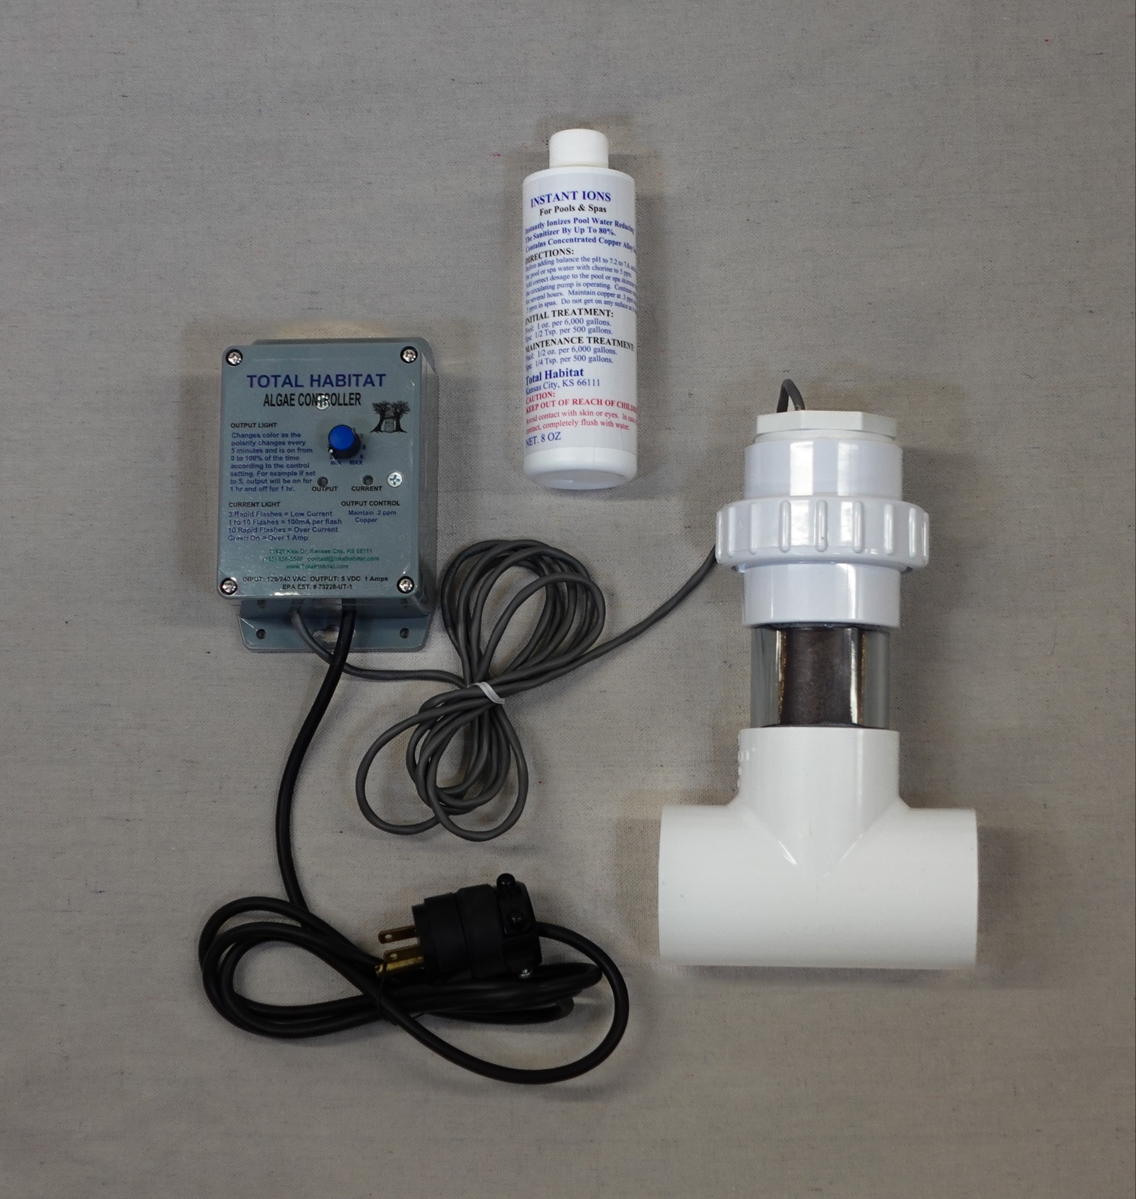
Keep these instructions in a safe place.

NOTE: The Algae Controller is effective against filamentous algae. You may still experience water borne algae which is controlled by other treatments such as the biological filtration system, dye, or UV sterilizers. The ionizer will not conflict with these other treatments.

